Posted 08/28/2012 at 12:29 pm by JAV

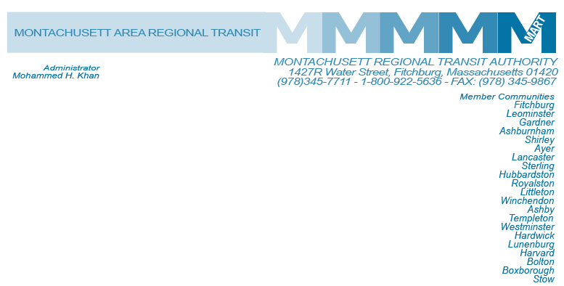

MEETING OF THE MART ADVISORY BOARD
MART Maintenance Facility
1427R Water Street
Fitchburg, MA 01420

Wednesday September 12, 2012
10:30 A.M.

Tentative Agenda

- Call to Order

- General Comments
A. Terry Turbide a long standing supporter and user of MART Services, a regular attendee of MART Advisory Board Meetings and a champion for the disabled population of the region passed away recently.
- Approval of February 16, 2012 Minutes
RESOLUTION 701 - BE IT RESOLVED that the Advisory Board of the Montachusett Regional Transit Authority approves the February 16, 2012 minutes as presented.

IV. Financial Matters
A. Status of State Funding
B. Status of Federal Funding
1. Section 5307 Funding
2. TIGGER II Grant
3. State of Good Repair Grant – Buses
4. State of Good Repair Grant – Facility Upgrades
5. Clean Fuels Grant
C. Appointment of a New Auditor FY2013, Stowe and Dengo LLC.
D. Proposed FY13 Budget for Board Approval
RESOLUTION 702-BE IT RESOLVED that the Advisory Board of the Montachusett Regional Transit Authority approves the FY2013 Budget as presented by its Administrator, with a total local assessment not to exceed $1,789,212 in accordance with proposition 2 ½.
D. Revenue Anticipation Note Renewal for August $19,800,000 @ 0.62%

V. Administrative Matters
A. Nomination of Officers
Existing Officers Chairperson – Mayor Lisa Wong
Vice Chairperson – Mayor Mark Hawke
B. Gardner Mayor to appoint a nonvoting member from the disabled community to the Advisory Board. This member will serve on the board for 1 year.
C. RESOLUTION 703 -BE IT RESOLVED that the Advisory Board of the Montachusett Regional Transit Authority approves that in the absence or unavailability of the Administrator, the Deputy Administrator shall assume authority and duties of the Administrator.
D. Triennial Review

E. Revised Drug and Alcohol Policy Presentation
RESOLUTION 704 -BE IT RESOLVED that the Advisory Board of the Montachusett Regional Transit Authority has considered and been made aware of its Revised Drug and Alcohol Policy, as presented by the Program Manager, and adopts the policy.

Capital Equipment/Facilities
- Status of A & E Design - North Leominster Park and Ride Commuter Rail Parking Facility
Construction activities are already underway, initial site work has been completed and an underground stone culvert has been replaced with concrete piping and new manhole structures. Work has now commenced on footings and foundations which are approximately 40% complete. Steel placement should begin towards the end of October. Relocation of utility poles and wires is also underway and should be completed by the end of September. Construction should be completed by mid- summer of 2013.
- Improvement to the Commuter Rail Corridor between Fitchburg and Boston
The project is currently funded at $150 million with 50% State funds and 50% Federal funds. In addition, MBTA has allocated another $40 million Stimulus Money to accomplish the double track and signal system. Work on the project is continuing including the new crossover located in Leominster, as well as improvements to the track along the corridor. Initial work on the construction of Littleton Station has begun including track and signalization work. The design of the station for South Acton is continuing towards completion and the completed improvements to the commuter rail line are scheduled to be completed in the third quarter of CY2014.
C. Wachusett Commuter Rail Extension Project – Station, Parking and Layover Facilities
MART continues to actively work with the City of Fitchburg, the Town of Westminster, Pan Am, the MBTA and their design consultants (Jacobs Engineering for the Station and Platform, Surface Parking Lot and Layover facility / HNTB for all track and signal design). The 100% design by Jacobs has been completed and released for review to Westminster and Fitchburg, while the track and signal design by HNTB has reached the 60% level. The MBTA has hired URS as their Project Manager/Construction Manager to oversee the construction of the project. Substantial project completion is expected in December 2013 with full completion in the spring of 2014.
D. Parking Improvement at Ayer-Rail Trail Facility
MART has received FTA’s concurrence for the previously submitted Categorical Exclusion (CE) which agrees that the Ayer project does not impact historic properties. MART will begin the process of submitting a grant application to the FTA for approval, as well as working on an RFP to select an A & E firm to begin design and engineering work on the surface parking facility.
VII. Operational Services and Status Reports
A. MART Operation Status on Revenue and Ridership
1. Fitchburg/Leominster
2. Gardner and Mount Wachusett Community College
3. ADA Service
4. Council on Aging (COA)
5. Veterans/COA Out of Town
6. Dial-A-MART
VIII. HST Status Reports
- MassHealth Transportation Program
- Department of Public Health EI Program
- Department of Developmental Services Program
- Special Needs Transportation Program

IX. Other Business

X. Adjournment
C: City and Town Clerks: Please post this notice pursuant to MA General Laws Chapter 30A,
Section 11 ½.

